**Business Trip CA**

**Request Data List**

**Request Form**

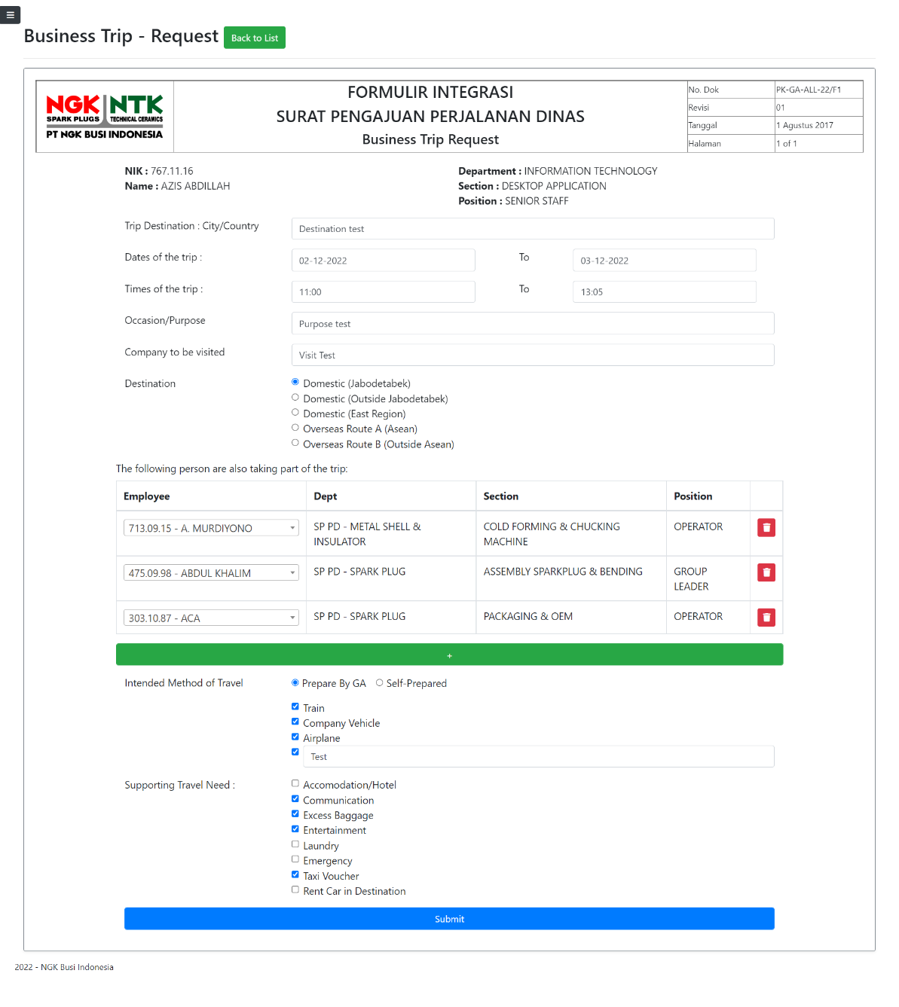

**Cash Advance**

**Data List**

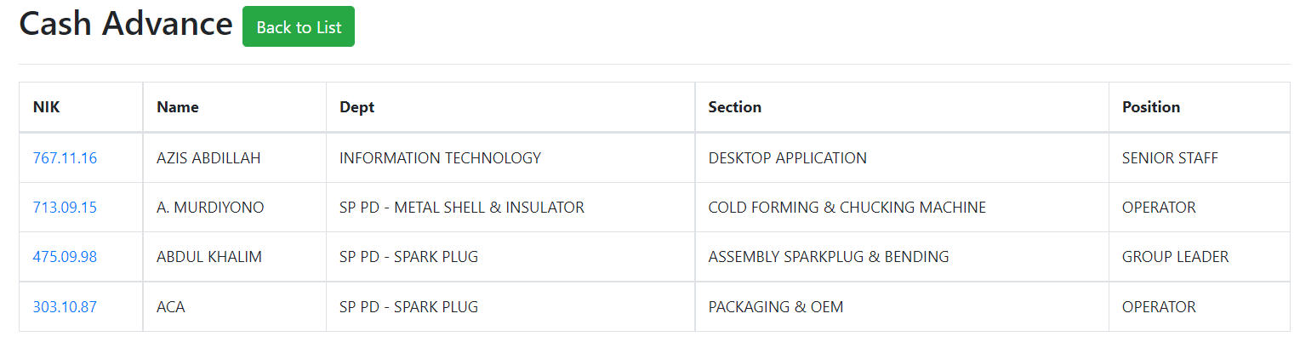

**Form**

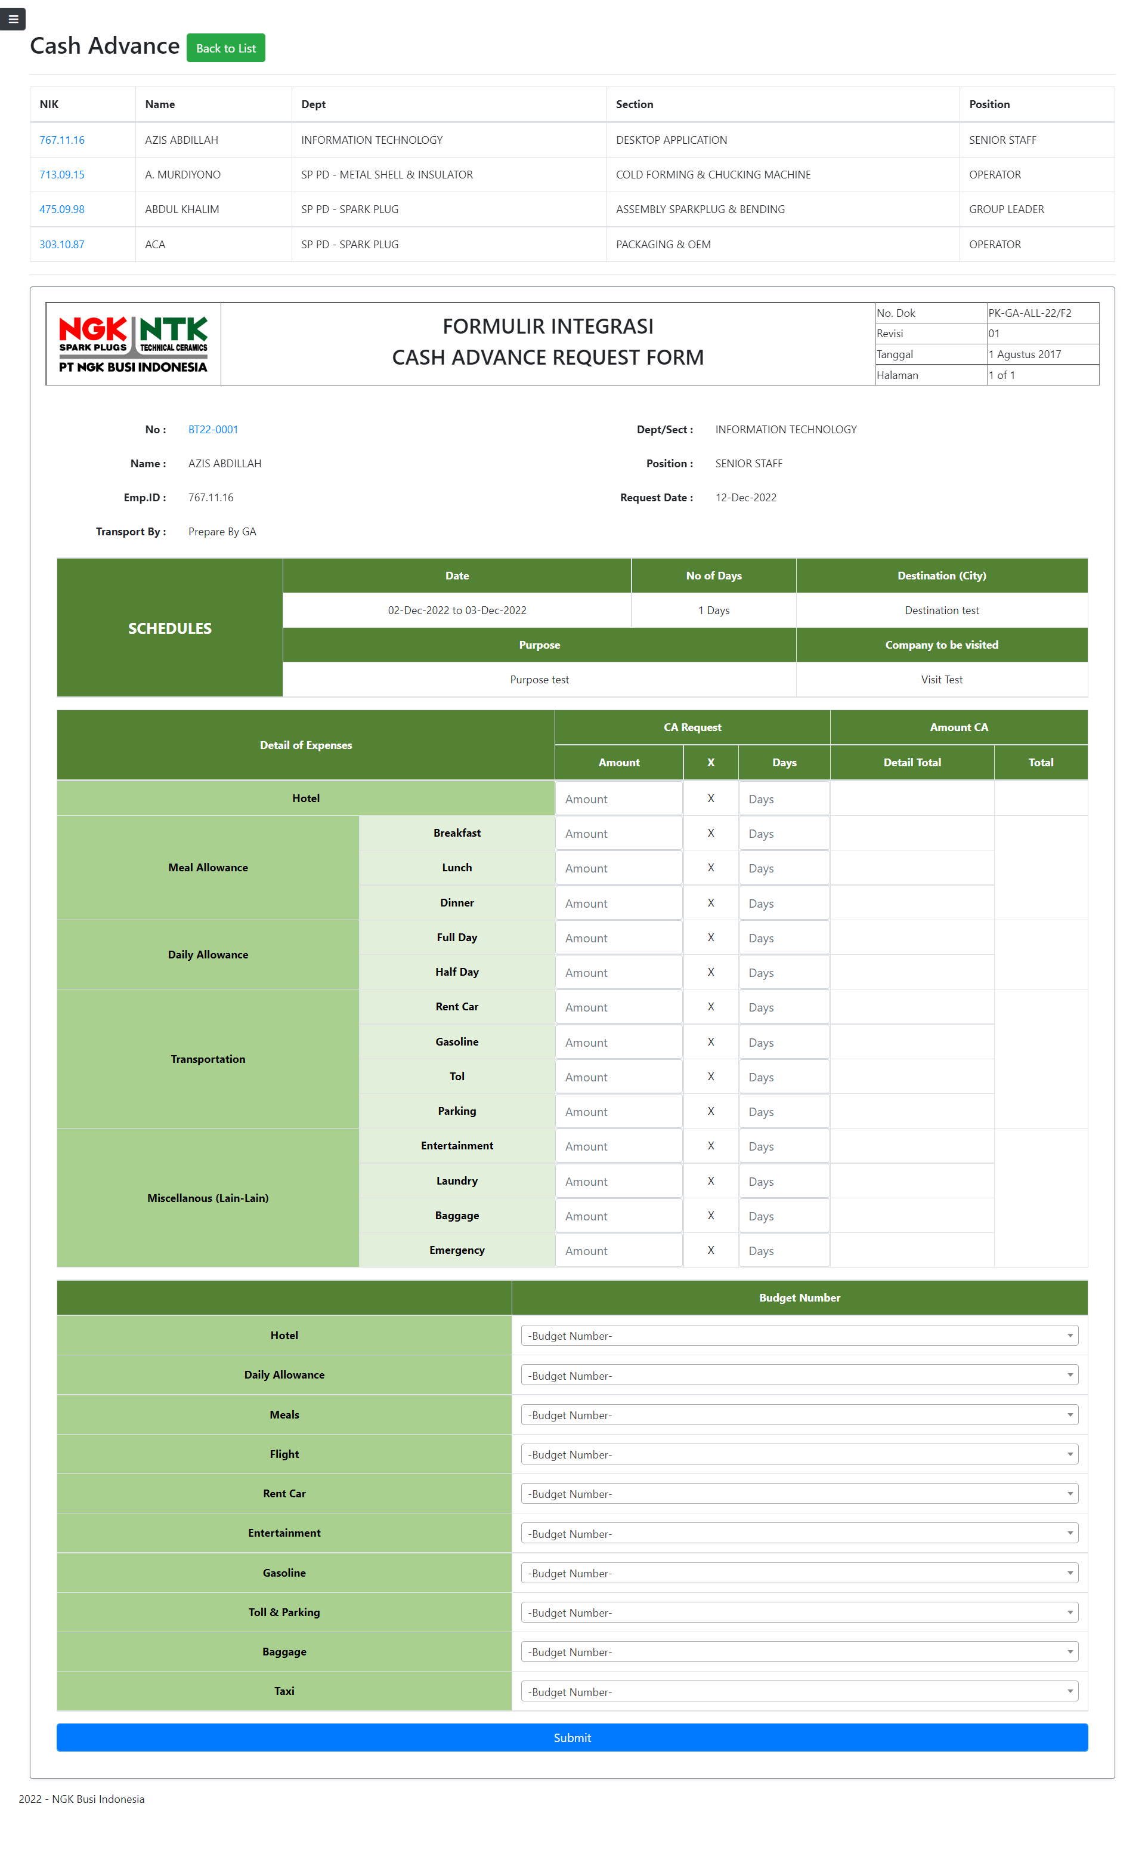

**SIK Online**

**Data List**

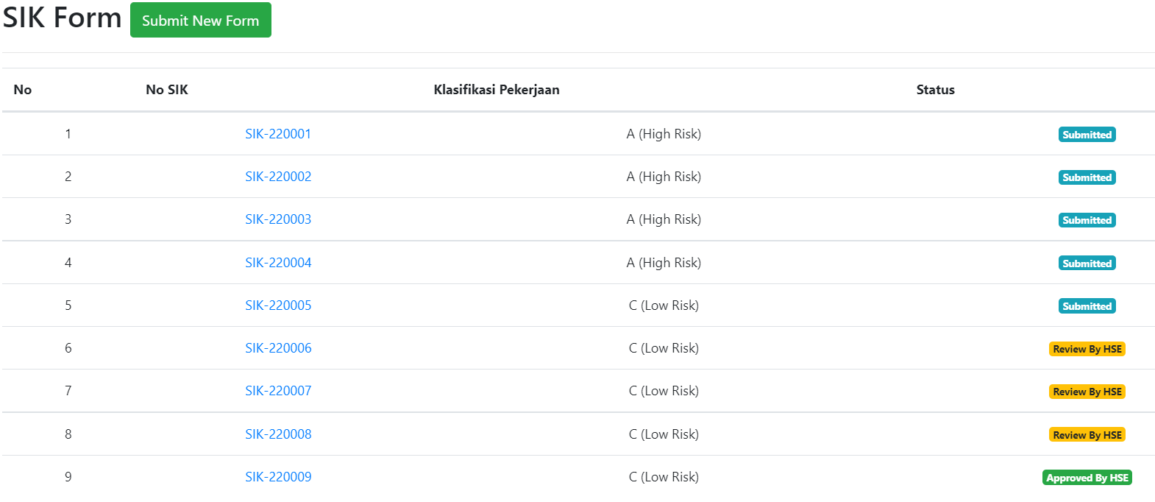

**Form**

**Daily Form**

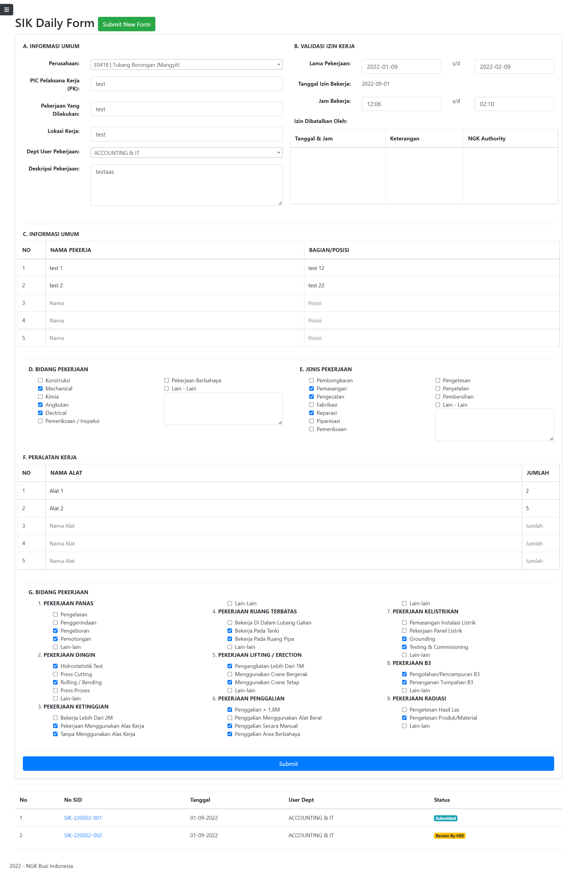

**Daily Check List** 